Name :-Kunal R Agarwal

SRN No:-201700110

Roll No:-18

Question:-**Implement candidate elimination algorithm on given data set.**

**Input:-**

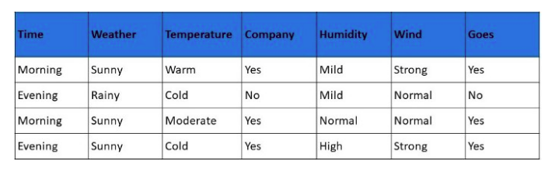

**Code:-**

import numpy as np

import pandas as pd

import os

data=pd.read_csv("../input/salgo/S-ALgo.csv")

d = np.array(data)[:,:-1]

print(" The attributes are: ",d)

target = np.array(data)[:,-1]

print(" The target is: ",target)

def train(c,t):

for i, val in enumerate(t):

if val == "Yes":

specific_hypothesis = c[i].copy()

break

for i, val in enumerate(c):

if t[i] == "Yes":

for x in range(len(specific_hypothesis)):

if val[x] != specific_hypothesis[x]:

specific_hypothesis[x] = '?'

else:

pass

return specific_hypothesis

print(" The final hypothesis is:",train(d,target))

**Output:-**

